Tastatura matriceala 4x4 cu conector pin de tip mama

Componente:

* 1 \* Raspberry Pi (Raspberry Pi Model 3 B+
* 1 \* Tastatura matriceala 4x4 cu conector pin de tip mama

<https://www.optimusdigital.ro/ro/senzori-senzori-de-atingere/470-tastatura-matriceala-4x4-cu-conector-pin-de-tip-mama.html>

Circuit:

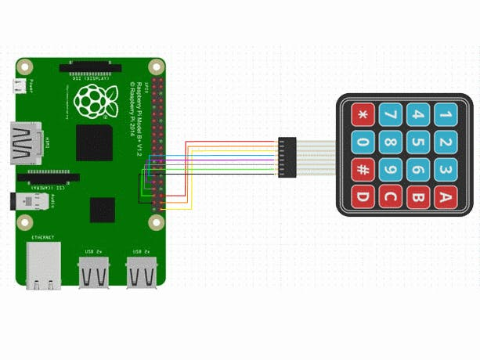

C code:

<https://github.com/srgian/internship_1903/commit/667a531b7d79cf79861ceebd5a16a02880a14bc6>